Design Phase of the Joint Project around the Senegal Mauritanian Aquifer Basin led by the Regional Working Group

Deliverable number 4:

Report on the assessment of available groundwater data

DOCUMENT STATUS: APPROVED BY THE REGIONAL WORKING GROUP

  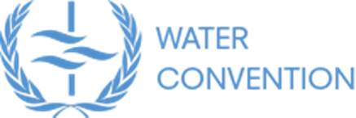 | 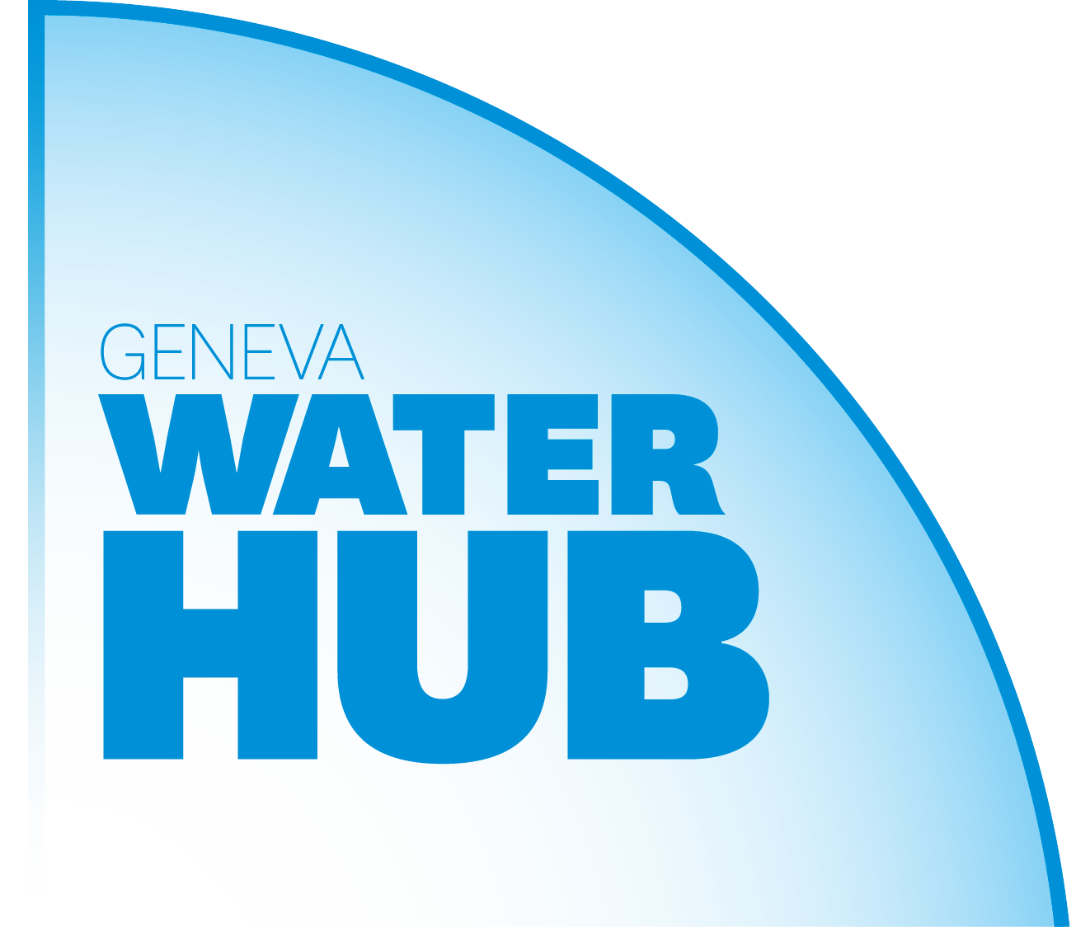 | 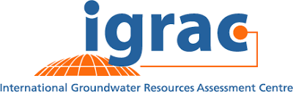
With the financial support of
 | 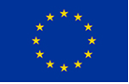 | 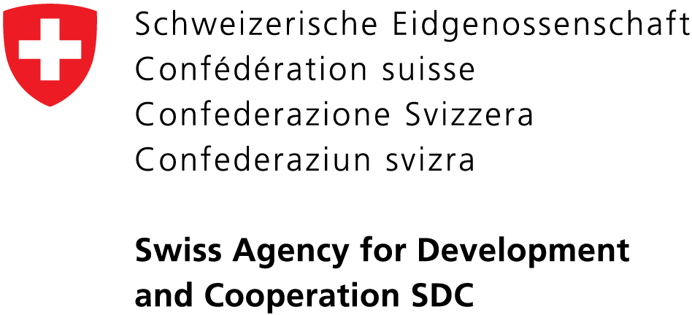

Table of Contents
1 Introduction 3
2 Inventory of groundwater maps and datasets 4
2.1 Geological maps 4
2.1.1 Gambia 4
2.1.2 Guinea-Bissau 4
2.1.3 Mauritania 4
2.1.4 Senegal 4
2.1.5 Regional map(s) 5
2.2 Hydrogeological maps 6
2.2.1 Gambia 6
2.2.2 Guinea-Bissau 6
2.2.3 Mauritania 6
2.2.4 Senegal 6
2.2.5 Regional map(s) 8
2.3 Borehole data 10
2.3.1 Gambia 10
2.3.2 Guinea-Bissau 10
2.3.3 Mauritania 11
2.3.4 Senegal 11
2.4 Groundwater monitoring data 12
2.4.1 Gambia 12
2.4.2 Guinea-Bissau 13
2.4.3 Mauritania 13
2.4.4 Senegal 13
3 Data availability and accessibility 14
4 Data processing 17
5 Conclusion 20

Introduction
This report provides an overview of existing data in the SMAB. It starts with a list of available groundwater maps and datasets (Section 2), including relevant metadata (e.g. references, coverage, date or period, format and accessibility). For this preliminary assessment of data, only the main groundwater maps and data available at the national or regional level have been considered: geological and hydrogeological maps, borehole data and groundwater monitoring data. Section 3 provides an overview of data gaps. Section 4 gives an impression of the work to be carried out to process the data into relevant information supporting the regional-scale assessment of the SMAB. In conclusion, a couple of recommendations is made for future works on data collection, data sharing and data processing.

As part of this data assessment activity, an online information portal was launched, where several maps and datasets are available (Figure 1). Maps were either collected online or in the scientific literature available. The sharing of hydrogeological maps from the “Synthèse Hydrogéologique de la Guinée-Bissau” was authorized by DGRH. The portal is accessible at:
https://apps.geodan.nl/igrac/ggis-viewer/viewer/basm/public/default

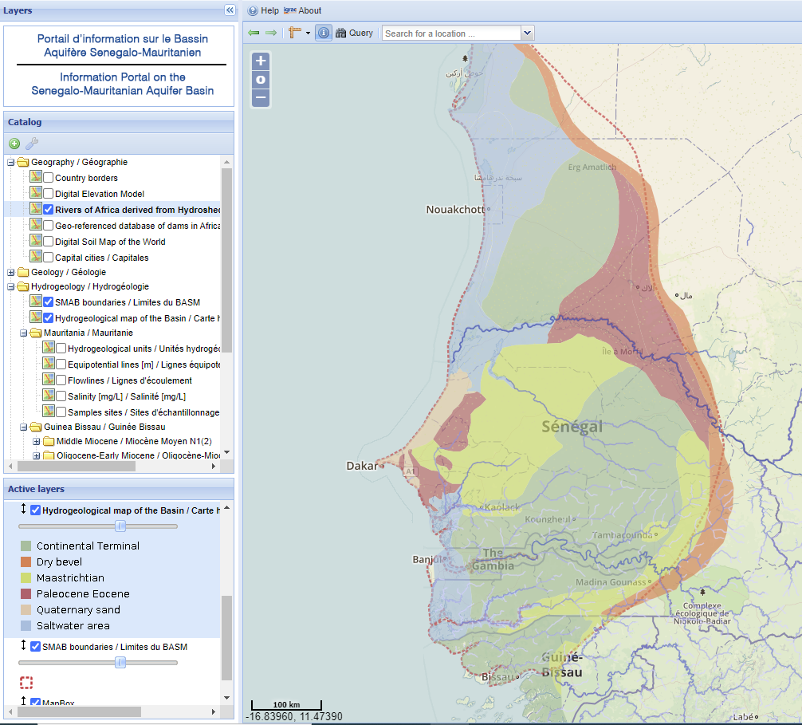
Figure 1 Snapshot of the SMAB information portal.

Inventory of groundwater maps and datasets
In this preliminary project phase, priority was given to the collection of basic groundwater maps and datasets: geological maps, hydrogeological maps, borehole data and monitoring data.

Geological maps

Gambia
A geological map of Senegal and the Gambia was published by BRGM in 1962. There is no recent geological map of the Gambia. Since the geology is uniform over the country, there is apparently not much need for updating the map.

Guinea-Bissau
A geological map of Guinea-Bissau was compiled by the Portuguese National Laboratory for Energy and Geology (LNEG) in 2011, at the scale 1:400 000. The map is available online in image format in the geoportal of LNEG.

Mauritania
A geological map at the scale 1:1000 000 was produced by USGS in 2015 in support of the mining sector in Mauritania. The map is available in shapefile format online.

Senegal
The geological map of Senegal is divided in 4 sheets (NW – NE – SW – SE) at the scale 1 :500 000. Three sheets (NW – NE – SW) were produced as part of the « Programme d’Appui au Secteur minier (PASMI) », a programme funded by EU to support the mining sector in Senegal. The 4th sheet was produced subsequently. The region surrounding the Senegal river is covered by 6 sheets at the scale 1 :200 000, which have been updated in 2009. All these maps fall under the responsibility of the Ministry of Industry and Mines of Senegal.
On request of the DGPRE, the Ministry of Industry and Mines of Senegal has shared 4 sheets at 1 :500 000 and 3 sheets at 1 :200 000. For some reason, the 3 other sheets at 1 :200 000 have not been shared. These maps have been shared at the condition that they are not shared outside the project team. The maps shared are in pdf. Apparently, the Ministry of Industry and Mines doesn’t have the original shapefiles. Those could be requested from the project team who created the maps (Geoter and BRGM), or from the EU delegation in Dakar who financed the project. Contacts could be taken with these organisations with the support of the Ministry of Industry and Mines.

Regional map(s)
There is a geological map of the basin modified and shared by Diene et al. (2015).

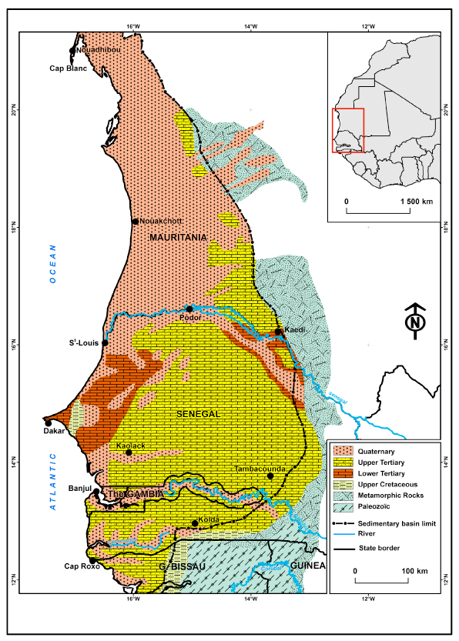
Figure 2 Geological map of the SMAB (in Diene et al. 2015).

Hydrogeological maps

Gambia
There is a hydrogeological map from 1987 (The Gambia Government), and an updated version from 2014 (National Water Sector Reform Studies, The Gambia). The version from 2014 is in shapefile format. The version from 1987 has been georeferenced. Since the distribution of aquifers is uniform over the country), the main information contained in the map is the value of hydraulic heads (piezometric contour lines).

Guinea-Bissau
Several maps have been published in the “Synthèse Hydrogéologique de la Guinée-Bissau” from 1991. Some of these maps have been vectorized and georeferenced by IGRAC.

Mauritania
A hydrogeological map at the scale 1:1000 000 was produced by USGS in 2015 in support of the mining sector in Mauritania. The map is available in shapefile format online.

Senegal
There is a hydrogeological map of Eastern Senegal from 2010, as well as an explanatory notice, apparently prepared as part of the PASMI project. None of these documents could be found. They could be requested at the Division of Industry and Mines in Dakar. There is another map at DGPRE from 2018 (Figure 3). This map is probably available in shapefile format.
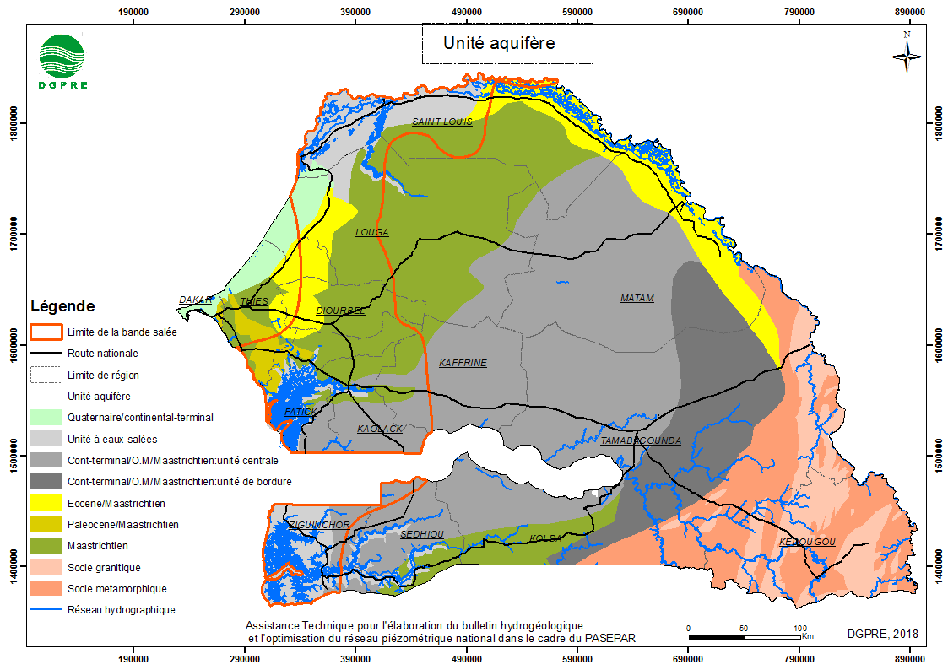
Figure 3 Aquifers map of Senegal (DGPRE, 2018).

Regional map(s)
A hydrogeological map of the SMAB was shared by Diene et al. (2015) (Figure 4).
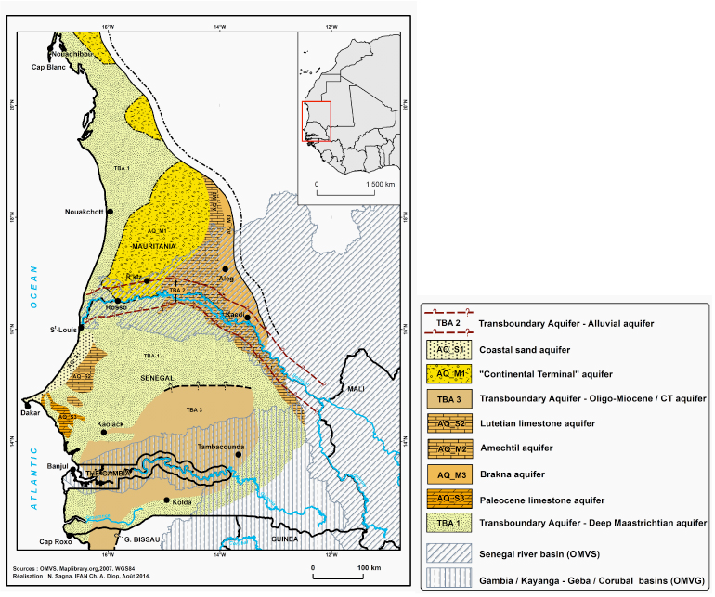
Figure 4 Hydrogeological map of the SMAB (in Diene et al. 2015).
Another map of the SMAB was published by UNESCO in 2005 (Figure 5). The original reference of this map is unknown. This map has been georeferenced and vectorized by IGRAC. A similar map was prepared by I. Mall (date unknown) (Figure 6), where hydrogeological units have the same contours but different names.
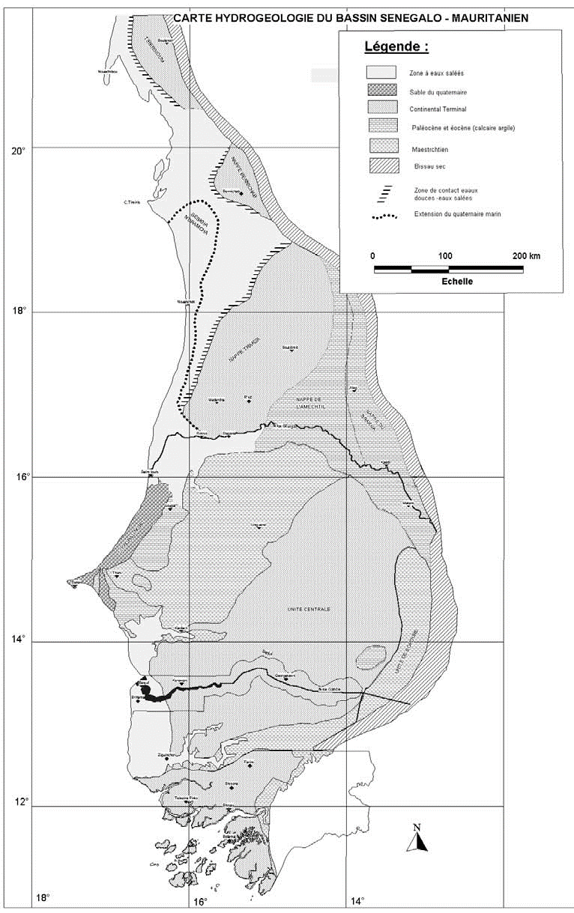  Figure 5 Hydrogeological map of the SMAB (in UNESCO 2006). | 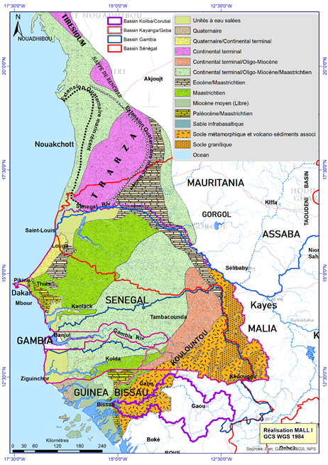  Figure 6 Hydrogeological map of the SMAB (I. Mall).

Borehole data

Gambia
There is no up-to-dated inventory of wells and boreholes in the Gambia. The last inventory of water points was made in 2014 by NIRAS (consultancy company), as part of the National Water Sector Reform Studies, where data were collected from different sources (Table 1). This inventory is at the Department of Water Resources (DWR). An ongoing project in the Gambia has the objective to update the inventory of water points in the country.
Table 1 Number of inventorised groundwater points by region in 2014(National Water Resources Assessment And Management Strategy)
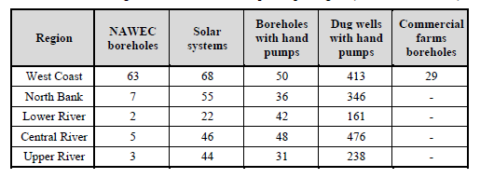

Guinea-Bissau
There is no systematic licensing or recording of boreholes in Guinea-Bissau. DGRH has an Access database of water points with 2225 records, containing the following data: geographic coordinates, DGRH Code, community name, population per community, water point typology (borehole, dug well, piezometer, spring), depth, type of hand pump, functionality, and water quality for few water points.
Recently, UNICEF supported DGRH in various surveys of the WASH sector in the country. The surveys included data related to groundwater:
- Borehole lithology Guinea Bissau (855 entries)
Data Available: geographic coordinates, DGRH code, borehole/design data, drilling data, pumping test data, physical-chemical data, borehole log etc.
- Groundwater quality in situ tests (hand pumps, improved dug wells and boreholes) (744 entries)
Data available: pH, temperature, turbidity, electrical conductivity, iron, nitrates, e.coli, total coliforms
- Water point visit (717 entries)
Data available: geographic coordinates, typology of water point (handpump, improved dugwell, borehole), type of hand pump/brand, functionality/status, mechanical problems, water depth, total depth, state of conservation of the water point (fence, apron, drainage from apron, wall, superstructure etc.), photo.
Data have been collected with the mWater app and are available in the mWaterPortal.

Mauritania
An inventory of boreholes falling within the SMAB boundaries was provided by the Ministry of Water and Sanitation (MHA). The inventory has slightly less than 5000 boreholes, including drillings, wells and piezometers (Table 2). Among other fields, the inventory contains the depth of the wells, the yield, one electrical conductivity value, one value of static water level and the type of pump (if any), the purpose of the well and whether it is productive or not. There isn’t information on the drilling method or the stratigraphy. The oldest data is from 1930, the latest from 2007. It seems to indicate that the database hasn’t been updated since 2007.

Table 2 Overview of borehole data in the provinces of Mauritania covered by the SMAB (MHA, 2020).
Type of construction | Number of constructions
Boring tests | 78
Hand dug wellls | 386
Modern wells | 3085
Piezometer | 218
Borehole | 960
Counter-well | 35
Dam | 2
Unkown | 123
Total | 4887

Senegal
All boreholes are reported to the DGPRE, where data are stored in a database. A copy of the database from 2015 was provided in pdf (it should be possible to have it in Excel format for subsequent analysis and harmonization with the datasets from other countries). In 2015, the database had more than 5.000 entries (drilling/well/piezometer) (Table 3) and it was up-to-date (last records were from 2015). The pdf export files that were provided contain information on the depth and the construction of the wells (screen intervals and position of the pump) but not the absolute elevation of the wells. They also contain the type of aquifer, the purpose of the wells, the yield and the drawdown during the pumping test (from which the specific capacity could be calculated), as well as one value of TDS and one value of fluoride. A database is currently being updated with the entry of drilling reports and piezometric monitoring, which could be shared when the sharing framework is put in place.

Table 3 Overview of borehole data in the national borehole database of Senegal in 2015.
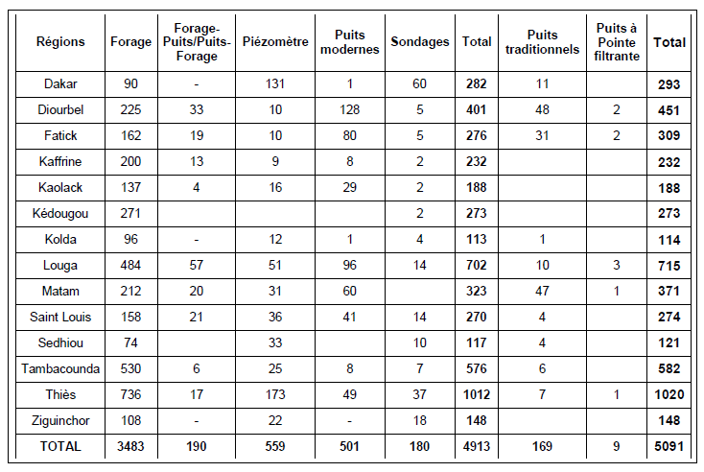

Groundwater monitoring data
No monitoring data were shared so far. Nonetheless, information was collected on how groundwater monitoring is organised in the four countries, which is presented in Deliverable 5. This section provides a brief overview of what monitoring data are available and where.

Gambia

There is a national monitoring network since 2014, with 38 boreholes installed with automatic data loggers, where data are downloaded monthly but sometimes could be less frequent. However, due to the high failure of data loggers, the data collection is currently being conducted manually which can be accessed at the Department of Water Resources (DWR). Groundwater quality is regularly monitored at about 100 locations, mainly covering water supply tanks and taps from the public utility (NAWEC). Groundwater samples are analysed by DWR with the financial support of the Public Utilities Regulatory Authority (PURA). Data is shared with PURA, but a copy of the data exists also at DWR. Groundwater abstraction is monitored only in the boreholes managed by NAWEC, the public water supply company.
Other water supply sources especially in the rural areas are hardly regularly tested and/or monitored for water quality. However, UNICEF also sponsors bi-annual water quality testing for many schools and vulnerable communities. It further provides funding for the chlorination of wells and hand pumps especially in the schools and post-flood emergency response.

Guinea-Bissau
A monitoring network was built in the nineties, with about 100 boreholes across the country. However, the network was abandoned after the civil war in 1998.

Mauritania
The National Centre of Water Resources (CNRE) has insufficient capacity for groundwater monitoring. Since 2000, groundwater monitoring is done at the wellfields by the National Water Supply Company (SNDE), including the wellfields of Idi, Boulenoir and Benichab. Groundwater level and quality data are taken twice per year on average. Boreholes are equipped with flowmeters. Groundwater monitoring is also carried out at the National Park of Diawling (part of the Ministry of Environment) but the data are not shared.

Senegal
Monitoring data are collected by the DGPRE across the country and by SONES near the wellfields. Groundwater levels and quality are monitored. Groundwater quality monitoring includes physical parameters, major ions and (only near the wellfields) microbiology. The number of wells monitored and the frequency of monitoring by DGPRE depends on the budget available, which itself depends partly on funded projects. In 2019, about 500 points were monitored, of which 290 were observation boreholes.

Data availability and accessibility
An overview of the availability of national and regional groundwater maps and datasets described in the previous section is given in Table 4. In terms of maps, all could be collected but those from Senegal. The Division of Industry and Mines has given the maps in pdf, upon request from DGPRE and at the condition that the maps are not shared outside the regional working group. The shapefiles could be requested from the consultants who made the maps (BRGM and Geoter), with the support of the Division of Industry and Mines.
Borehole data have been obtained from Senegal and Mauritania. The DGRH of Guinea-Bissau has given access to the mWater portal, which contains an inventory of boreholes. The inventory of boreholes from 2014 in the Gambia is at DWR and it shouldn’t be a problem to get access to these data.
No monitoring data have been shared so far. In transboundary projects, the sharing of groundwater monitoring data is usually the most challenging. There are two reasons for that. One is that monitoring data combine a spatial and a temporal component, for which it is more challenging to store them in the computer. Storing monitoring data in Excel format can quickly become tedious, for which it is often required to use an advanced relational database. Therefore, sharing monitoring data is not as easy as sharing one spreadsheet containing borehole data. The second reason is that monitoring data can be considered as sensitive, in particular groundwater quality data. The use of data exchange platforms with private workspaces could be helpful, like in previous TBA assessment projects. It will be necessary to discuss with the aquifer sharing countries and partners to understand if and where there are hindrances to the sharing of groundwater monitoring data.
Geological and hydrogeological maps are available in every country. A preliminary inspection of hydrogeological maps suggests that significant efforts will be needed to harmonize the maps at the scale of the SMAB (see next section). The inventory of boreholes is not complete in Gambia, in Guinea-Bissau, and apparently in Mauritania. The monitoring of groundwater is reportedly insufficient in Gambia, Guinea-Bissau and Mauritania (see Deliverable 5). Such activities could be supported by a transboundary cooperation project. Depending on scope, such cooperation project could benefit from the collection of additional maps and datasets supporting the comprehensive assessment of groundwater resources, such as other environmental data or socio-economic data. As an example, IGRAC and UNESCO-IHP proposed a list of parameters and variables to be collected to assess transboundary groundwater resources (Table 5). Furthering the dialogue among the aquifer sharing countries can be expected to be helpful for understanding which data would be most useful and of mutual interest to share, e.g. for the purposes of assessing development potential of the different geological units or depths at which groundwater can be found, as well as identification of zones where groundwater may be under more pressure in terms of quantity or quality either already or in the future. A useful exercise for clarifying information needs and priorities may be to assess data availability more broadly and in relation to management issues identified (deliverable 5).

Table 4 Overview of data availability and accessibility.
 | Gambia | Guinea-Bissau | Mauritania | Senegal | Regional scale
Geological map | At BRGM. | Obtained online | Obtained online | Obtained from Division des Mines | Obtained online
Geological map | Hardcopy | Georeferenced image | Shapefile | Pdf (shapefile must be available) | Image
Hydro-geological map | Obtained from DWR (contour map) in pdf. Shapefile available at DWR | Obtained from DGRH | Obtained online | Probably available at Division des Mines | There are several maps available (with consistency issues)
Hydro-geological map | Shapefile | Image/Shapefile | Shapefile | Shapefile | Image/Shapefile
Borehole data | Available at DWR. Currently being updated. | Obtained online (mWater). | Obtained from MHA but no data since 2007 | Obtained from DGPRE in pdf. Excel copy available at DGPRE
Monitoring data | Available at DWR | There is no systematic monitoring | Available at SNDE | Available at DGPRE

Table 5 List of data commonly useful to collect for transboundary groundwater assessment (in the case of the present project, socio-economic data is considered in deliverable 3 and data on the legal and institutional aspects in deliverables 6 and 7).
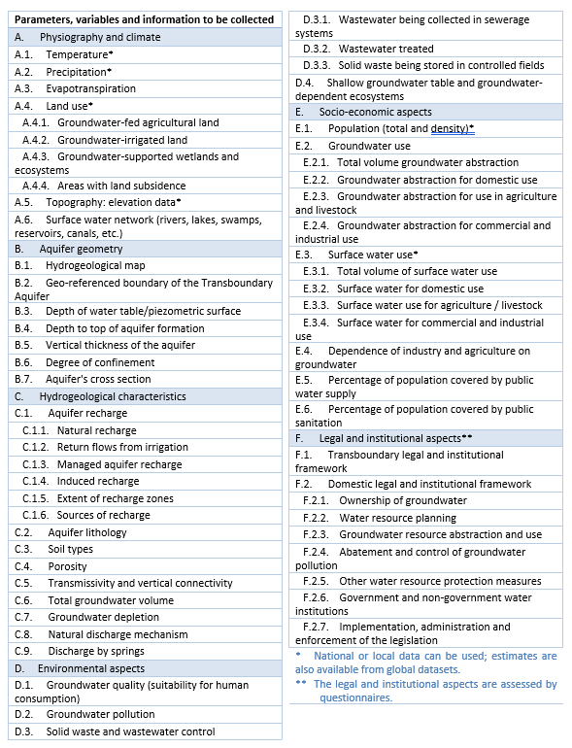

Data processing
As most datasets are at the national scale, efforts would be necessary for aggregating the data at the scale of the SMAB, for the purpose of a common, regional assessment of groundwater resources (as illustrated in Figure 7), which would provide a helpful information basis for further development of cooperative activities. These efforts can include:
- Georeferencing and vectorizing maps. Maps in image format (like jpeg or pdf) can’t be opened in a GIS software. The image has to be georeferenced, using reference points. For analysis, it is better to convert the image in a vector file format, such as shapefile. This second step is particularly time-consuming and sometimes impossible when the resolution of the image is too low. If the geological maps of Senegal cannot be found in shapefile format, it will be necessary to go through that process of georeferencing and vectorizing.
- Quality control. This applies in particular to borehole datasets and monitoring datasets, where it is not uncommon to find errors or inconsistencies. Visual inspection of the data or simple automated checks can be used to detect suspicious data. These can be flagged or removed from the regional datasets.
- Data harmonization. Different standards and terminology can be in use in the different countries. For instance, the coordinate systems can be different; groundwater levels can be expressed in elevation above the sea level or in depth from the top of the borehole; etc.
- Interpretation and analysis. This is the actual assessment of groundwater in the SMAB, which serves to inform the management of these resources. After this final step, it should be clear whether the assessment is complete or whether additional data need to be collected (if yes: what data and where?)
As few datasets have been collected to date, in the right format, it was only possible to estimate the amount of work to harmonize the national and regional hydrogeological maps. As illustrated in Table 6, the hydrostratigraphic units differ in the different maps. Their names change (units are named after their age, their lithology or from a local name) and they are not individualized on the same basis. The contours of the units were not compared because the shapefiles of the national map of Senegal have not been accessed yet. Nonetheless, a significant amount of work would be necessary to produce a harmonized map of the SMAB, for which it might be necessary to look into the original stratigraphic logs of the boreholes. This process could lead to a more significant breakthrough if the mapping of hydrogeological units is made in 3D and not only in 2D, i.e. if the depth and thickness of the units is also estimated. A 3D hydrostratigraphic model of the basin could help visualize the recharge areas, the flow directions, where aquifers are confined, where they can be tapped with boreholes, etc. It could also be used subsequently to compute a regional groundwater flow model.
Other types of data, including groundwater quality, would involve further harmonization considerations and comparison of approaches, including to indicators, parameters, methodologies and standards referred to.

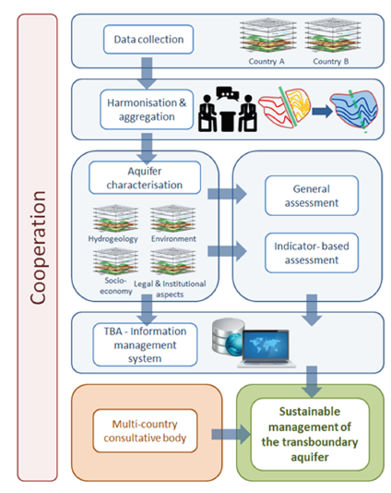
Figure 7 Stepwise assessment of transboundary groundwater assessment (IGRAC and UNESCO-IHP, 2015).
Table 6 Comparison of hydrogeological units in the SMAB, as reported in available hydrogeological maps (the order of the countries is from South to North).

Conclusion
All countries have hydrogeological maps. There are also regional maps available. Although the collection of borehole data and monitoring data is reportedly insufficient in all 4 countries, there are borehole datasets and monitoring datasets available. However, only a part of these maps and datasets could be collected during this preliminary phase of the project, or they could be collected but not in a format that allows the maps and the datasets to be processed and analysed (i.e. maps and datasets in pdf format cannot be opened in GIS software or Excel). It will be necessary to exchange with the aquifer sharing countries and partners to see how and under what conditions the data could be shared. Only when data are shared it will be possible to make a regional assessment of groundwater resources (for instance, a regional map of boreholes and wells could serve as a proxy to determine where groundwater is the most used) and to determine where additional data are needed, i.e. where groundwater monitoring networks could be expanded (also to capture transboundary groundwater flow). Significant efforts will be needed to process the data: georeferencing and vectorising maps (if necessary), checking the quality of the data, harmonizing the maps and datasets, end eventually analysing and interpreting them. Without access to the data, it was only possible to evaluate the amount of work to harmonize the hydrogeological maps over the SMAB, which will be considerable. Furthermore, additional datasets would be beneficial to collect to assess groundwater resources taking into account environmental and socio-economic aspects. For strategic prioritization of such broader data collection efforts, these would best be guided by close linking with and assessment of the groundwater management issues at stake.

Carte géologique de la République du Sénégal et de la Gambie établie par le Bureau de recherches géologiques et minières ; [République du Sénégal], Ministère des Travaux publics, de l'habitat et de l'urbanisme, Service des mines et de la géologie
https://sig.lneg.pt/server/services/CartaGuine/MapServer/WMSServer?request=GetCapabilities&service=WMS
Bradley, D.C., Motts, H.A., Horton, J.D., Giles, Stuart, And Taylor, C.D., 2015, Geologic Map Of Mauritania (Phase V, Deliverables 51a, 51b, And 51c), Chap. A1 Of Taylor, C.D., Ed., Second Projet De Renforcement Institutionnel Du Secteur Minier De La République Islamique De Mauritanie (PRISM-II): U.S. Geological Survey Open-File Report 2013‒1280-A1, 3 Pl., Scale 1:1,000,000, http://Dx.Doi.Org/10.3133/Ofr20131280 [In English And French.]
https://pubs.usgs.gov/of/2013/1280/GIS_and_Maps/Chapter_A1_deliverable_51-Geology/Map%20PDF/
Roger J., Duvail C., Barusseau J.P., Noël B.J., Nehlig P., Serrano O. (2009b) – Carte géologique du Sénégal à 1/500 000, feuilles nord-ouest, nord-est et sud-ouest. Ministère des Mines, de l’Industrie et des PME, Direction des Mines et de la Géologie, Dakar, 3 coupures
Roger J., Noël B.J., Barusseau J.P., Serrano O., Nehlig P., Duvail C. (2009a) – Notice explicative de la carte géologique du Sénégal à 1/500 000, feuilles nord-ouest, nord-est et sud-ouest. Ministère des Mines, de l’Industrie et des PME, Direction des Mines et de la Géologie, Dakar, 61 pages.
Théveniaut, H., Duvail, C., Ndiaye, P.M., Fullgraf, T., Delor, C., Goujou, J.C., Buscail, F., et Diagne, E., 2010a. Carte géologique à 1/500 000 du Sénégal, feuille SUD-EST. Ministère des Mines, de l’Industrie, de l’Agro-Industrie et des PME, Direction des Mines et de la Géologie, Dakar.
Moustapha Diène, Cheikh Hamidou Kane, Déthié Sarr (2015). Overview of the aquifer system in the Senegalese and Mauritanian sedimentary basin. Revue Cames – Sci. Appl. & de l’Ing., Vol. 1(2), 86-91. ISSN 2312-8712.
Synthèse hydrogéologique de la Guinée-Bissau. GBS/87/002 Direction Générale des Ressources Hydriques PNUD/DCTD 1991
Friedel, M.J., Finn, C.A., and Horton, J.D., 2015, Hydrogeologic map of Mauritania (deliverable 56), Synthesis of hydrologic data (phase V, deliverable 57), and chemical hydrologic map of Mauritania (added value), chap. C of Taylor, C.D., ed., Second projet de renforcement institutionnel du secteur minier de la République Islamique de Mauritanie (PRISM-II): U.S. Geological Survey Open-File Report 2013‒1280-C, 28 p., 2 pl., scale 1:1,000,000, http://dx.doi.org/10.3133/ofr20131280 [In English and French]
https://pubs.usgs.gov/of/2013/1280/GIS_and_Maps/Chapter_C_deliverable_56_and_added_value-Hydrogeology/Map%20PDF/
Wuilleumier A, Théveniaut H, Mall I et Ndiaye PM. 2010. Carte hydrogéologique à 1/500 000 du Sénégal oriental, Ministère des Mines, de l’Industrie, de l’Agro-Industrie et des PME, Direction des Mines et de la Géologie, Dakar.
Wuilleumier A, Théveniaut H, Mall I et Ndiaye PM. 2010. Notice de la carte hydrogéologique à 1/500 000 du Sénégal oriental, Ministère des Mines, de l’Industrie, de l’Agro-Industrie et des PME, Direction des Mines et de la Géologie, Dakar.
Moustapha Diène, Cheikh Hamidou Kane, Déthié Sarr (2015). Overview of the aquifer system in the Senegalese and Mauritanian sedimentary basin. Revue Cames – Sci. Appl. & de l’Ing., Vol. 1(2), 86-91. ISSN 2312-8712
Ressources en Eau Et Gestion Des Aquifères Transfrontaliers de l’Afrique Du Nord Et Du Sahel - Analyse Globale (2005) ISARM-AFRICA, IHP-IV, Series on groundwater No. 11.”, p.94
https://portal.mwater.co/#/dashboards/02bba9ea86e5495682add83745522284
IGRAC & UNESCO-IHP (2015) Draft Guidelines for Multidisciplinary TBA Assessment. https://www.un-igrac.org/resource/draft-9-2015-guidelines-multidisciplinary-assessment-transboundary-aquifers
Helpful resources identification of information needs in relation to management issues are Strategies on Monitoring and Assessment of Transboundary Rivers, lakes and Groundwaters (UNECE, 2006).
The aspects are elaborated on, for example, in the Guidelines on Monitoring and Assessment of Transboundary Groundwaters (UNECE) developed under the Convention on the Protection and Use of Transboundary Watercources and International Lakes.

